Individual Task 01: Research and present a timeline showing major milestones in AI history.
Timeline of Major Milestones in Artificial Intelligence
1)Foundations and Early Development (1940–1970)
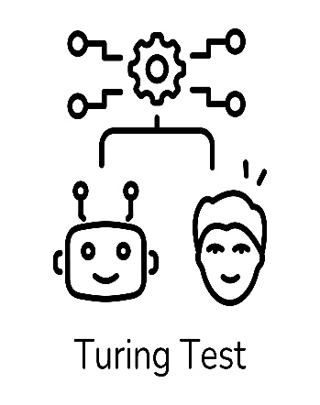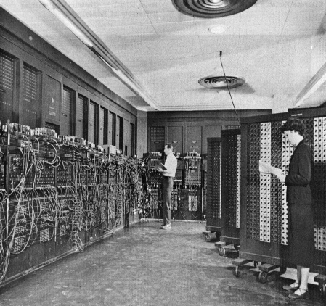
Fig. 1: Alan Turing and the Turing Test
1943 – Artificial Neuron Concept
Warren McCulloch and Walter Pitts proposed the first mathematical model of an artificial neuron, laying the foundation for neural networks. This work showed that biological brain functions could be represented using logic and mathematics.
1950 – Turing Test
Alan Turing introduced the Turing Test, a method to evaluate a machine’s ability to exhibit intelligent behaviour indistinguishable from a human. This became a philosophical and practical benchmark for AI.
1956 – Birth of Artificial Intelligence
- The term “Artificial Intelligence” was officially coined at the Dartmouth Conference, organized by John McCarthy and others. This event is considered the formal beginning of AI as a research field.
1960s – Early AI Programs
- Early symbolic AI systems such as game-playing programs and theorem provers were developed. AI research mainly focused on rule-based reasoning and logical problem solving.
Key Contributions and Limitations of Early AI
- The major limitation of early AI was its dependence on hard-coded rules, which made systems inflexible and unable to adapt to new scenarios. However, this phase laid the theoretical foundation for future learning-based models.
- Introduced the concept of machine intelligence
- Established formal evaluation methods (Turing Test)

Key Insight:
- This early phase of Artificial Intelligence established the theoretical foundation of machine intelligence. However, systems were limited by lack of learning capability and computational power, making them suitable only for controlled environments.

2) AI Winter, Expert Systems, and Machine Learning Shift (1970–2000)
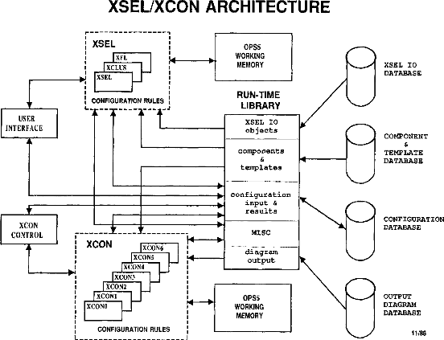
Fig. 2: Architecture of an Expert System
1974–1980 – First AI Winter
Due to limited computing power and unrealistic expectations, AI research funding declined sharply. This period is known as the AI Winter.
1980s – Expert Systems Era
AI regained attention through Expert Systems, which mimicked human expertise.
Example: XCON, used for computer configuration in industries.
Late 1980s – Second AI Winter
Expert systems proved expensive and difficult to maintain, leading to another decline in AI enthusiasm and funding.
1997 – Deep Blue vs Human Intelligence
IBM’s Deep Blue defeated world chess champion Garry Kasparov.
This event demonstrated that machines could outperform humans in complex decision-based tasks.
Late 1990s – Rise of Machine Learning
AI research shifted from hand-coded rules to Machine Learning, where systems learn patterns directly from data using statistical methods.
Why Expert Systems Failed
Despite early success, expert systems were difficult to maintain and required constant manual updates. They lacked scalability and could not learn from new data, which limited their long-term effectiveness.
As problem complexity increased, traditional rule-based AI became inefficient, leading researchers to explore data-driven approaches.
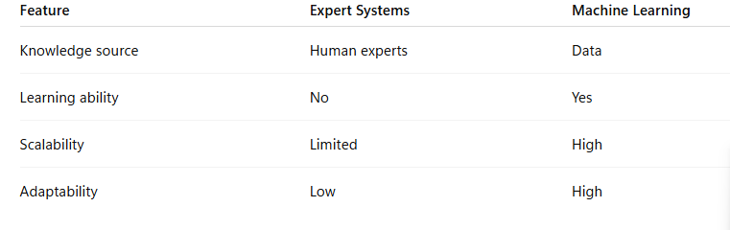
Technical Limitation:
- Expert systems depended heavily on manually coded rules, which made them difficult to scale and maintain.
- This limitation led to the shift toward data-driven Machine Learning approaches that could adapt automatically.
3) Deep Learning and Modern AI Era (2000–Present)
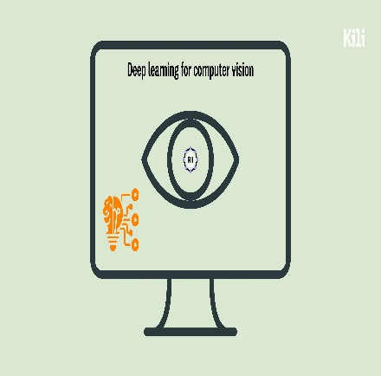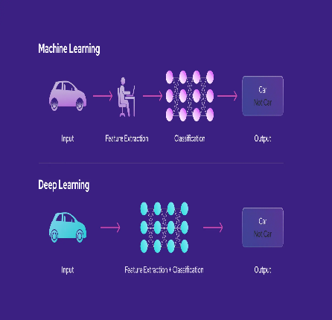
Fig. 3: Deep Learning Applications in Modern AI
2000s – Data-Driven AI
With the growth of the internet and big data, AI systems improved significantly in areas like:
- Search engines
- Speech recognition
- Recommendation systems
2012 – Deep Learning Breakthrough
Deep neural networks achieved record-breaking accuracy in image recognition tasks, marking the Deep Learning Revolution.
2016 – AlphaGo Achievement
DeepMind’s AlphaGo defeated Go world champion Lee Sedol.
This milestone proved AI’s capability in strategic thinking and reinforcement learning.
2020s – Generative and Responsible AI
Modern AI systems can now:
- Generate text, images, and code
- Assist in education, healthcare, and industry
- Raise ethical concerns related to bias, privacy, and safety
- Voice assistants and chatbots
Impact on Society:
Modern AI systems have transformed industries such as healthcare, transportation, and education by enabling
automation, prediction, and intelligent decision-making. Ethical and responsible AI development has become
a major focus in recent years.
Conclusion:
The evolution of Artificial Intelligence highlights a gradual transition from symbolic reasoning to
data-driven and learning-based models. Each stage contributed critical concepts that enabled the development
of modern intelligent systems. Today, AI continues to evolve with a strong emphasis on efficiency, scalability,
and ethical responsibility.

